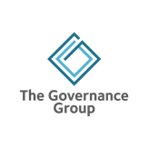
Not-for-profit board – stakeholder analysis

Stakeholder | What unique value do we provide them? | What unique value do they provide us?
Client
Volunteer

Member

Staff

Board member

Community

Funder

Donor

Other

